**The Battle of the Neighborhoods**

# Introduction

Sometimes we have to change our location because of many reasons: work, study, family… This project will help someone to understand how similar two areas from different cities are. As an example, we will try to compare two areas of two cities: Moscow and New York. Similarity of two areas can help to make a decision about migration from one city to another or about business expansion or just can provide some interesting information about two areas from different sides of the globe.

# Data

Most of initial information will be scraped from Wikipedia - free and open data source. Most detailed information about every location will be obtained using Foursquare API.

Based on definition of our problem following data sources will be needed to extract/generate the required information:

* geographical coordinates of the studied cities
* territory division
* initial information about every area

New York City (NYC) is the most populous city in the United States. With an estimated 2018 population of 8,398,748 distributed over a land area of about 302.6 square miles (784 km2), New York is also the most densely populated major city in the United States. A global power city, New York City has been described as the cultural, financial, and media capital of the world, and exerts a significant impact upon commerce, entertainment, research, technology, education, politics, tourism, art, fashion, and sports. Situated on one of the world's largest natural harbors, New York City consists of five boroughs, each of which is a separate county of the State of New York. The five boroughs – Brooklyn, Queens, Manhattan, The Bronx, and Staten Island – were consolidated into a single city in 1898.

Moscow is the capital and most populous city of Russia, with approximately 12.6 million residents within the city limits. Moscow is the northernmost and coldest megacity on the Earth. Moscow is a major political, economic, cultural, and scientific center of Russia and Eastern Europe. It is the second-most populous city in Europe, the most populous city entirely within Europe, as well as the largest city (by area) on the European continent. Moscow has been ranked as the ninth most expensive city in the world and has one of the world's largest urban economies, being ranked as an alpha global city, and is also one of the fastest growing tourist destinations in the world. Moscow is home to the third-highest number of billionaires of any city in the world, and has the highest number of billionaires of any city in Europe. The city of Moscow is divided into twelve administrative okrugs. By its territorial expansion on July 1, 2012 southwest into the Moscow Oblast, the area of the capital more than doubled, going from 1,091 to 2,511 square kilometers (421 to 970 sq mi), resulting in Moscow becoming the largest city on the European continent by area; it also gained an additional population of 233,000 people.

First, we have to understand territory division of two cities to understand which areas should be explored. Then every area should be explored to define initial criteria of similarity. In the end - detailed exploration of chosen areas. Let’s look at two maps of Moscow and NYC with territory division (different colors – different Administrative Okrug (in Moscow) and boroughs (in NYC):

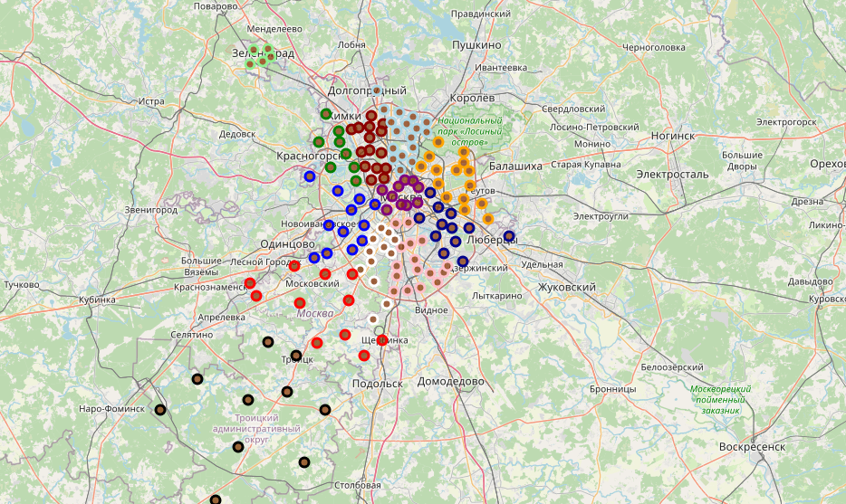

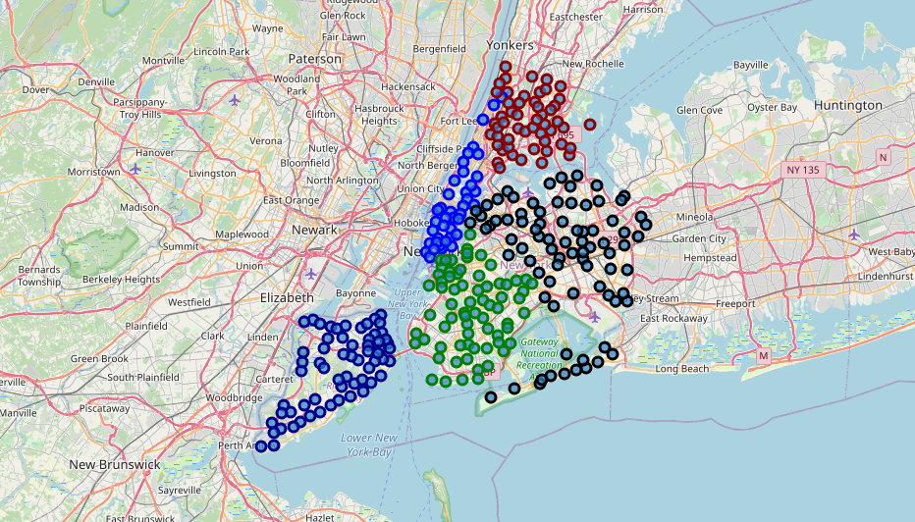

Now let’s have a look at numbers, which describes colored areas:

|  |  |  |  |  |  |  |  |  |  |
| --- | --- | --- | --- | --- | --- | --- | --- | --- | --- |
|  | Borough | Land area km² | % of all area | Place by area | Population | % of all population | Place by population | Density pers/km² | Place by density |
| 0 | The Bronx | 109.04 | 13.91 | 4 | 1418207 | 17.01 | 4 | 13006 | 3 |
| 1 | Brooklyn | 183.42 | 23.40 | 2 | 2559903 | 30.71 | 1 | 13957 | 2 |
| 2 | Manhattan | 59.13 | 7.54 | 5 | 1628706 | 19.54 | 3 | 27544 | 1 |
| 3 | Queens | 281.09 | 35.86 | 1 | 2253858 | 27.03 | 2 | 8018 | 4 |
| 4 | Staten Island | 151.18 | 19.29 | 3 | 476143 | 5.71 | 5 | 3150 | 5 |
| 5 | City of New York | 783.83 | 100.00 |  | 8336817 | 100.00 |  | 10636 |  |

|  |  |  |  |  |  |  |  |  |  |
| --- | --- | --- | --- | --- | --- | --- | --- | --- | --- |
|  | Administrative Okrug | Land area km² | % of all area | Place by area | Population | % of all population | Place by population | Density pers/km² | Place by density |
| 0 | Central | 66.18 | 22678 | 11 | 783886 | 43252 | 9 | 11845.56 | 5 |
| 1 | Northern | 113.73 | 18354 | 7 | 1188312 | 13759 | 7 | 10448.90 | 7 |
| 2 | North-Eastern | 101.88 | 43894 | 9 | 1434842 | 11994 | 4 | 14083.23 | 1 |
| 3 | Eastern | 154.84 | 41426 | 3 | 1527316 | 43963 | 2 | 9864.12 | 8 |
| 4 | South-Eastern | 117.56 | 23833 | 6 | 1433828 | 11628 | 5 | 12196.59 | 4 |
| 5 | Southern | 131.77 | 44682 | 5 | 1796267 | 14.17 | 1 | 13631.54 | 2 |
| 6 | South-Western | 111.36 | 15067 | 8 | 1448130 | 15646 | 3 | 13003.78 | 3 |
| 7 | Wester | 153.03 | 43988 | 4 | 1397114 | 43872 | 6 | 9129.42 | 9 |
| 8 | North-Western | 93.28 | 25263 | 10 | 1012949 | 36342 | 8 | 10859.11 | 6 |
| 9 | Zelenogradsky | 37.20 | 17168 | 12 | 250453 | 35796 | 11 | 6732.63 | 10 |
| # | Troitsky | 1084.34 | 42.92 | 1 | 130812 | 43891 | 12 | 120.64 | 12 |
| # | Novomoskovsky | 361.36 | 14.30 | 2 | 274140 | 42401 | 10 | 758.63 | 11 |
| # | All Moscow | 2526.53 | 100.00 |  | 12678079 | 100.00 |  | 4993.10 |  |

If we will use such features as land area, population and density to find similar areas, then we will stop on two candidates for further study:

|  |  |  |  |  |  |  |  |  |
| --- | --- | --- | --- | --- | --- | --- | --- | --- |
| Name | Land area km² | % of all area | Place by area | Population | % of all population | Place by population | Density pers/km² | Place by density |
| South-Eastern | 117.56 | 23833 | 6 | 1433828 | 11628 | 5 | 12196.59 | 4 |
| The Bronx | 109.04 | 13.91 | 4 | 1418207 | 43847 | 4 | 13006.00 | 3 |

And now let’s inspect neighborhoods of selected areas:

New York City:

|  |  |  |  |  |
| --- | --- | --- | --- | --- |
|  | Borough | Neighborhood | Latitude | Longitude |
| 0 | Bronx | Wakefield | 40.894705 | -73.847201 |
| 1 | Bronx | Co-op City | 40.874294 | -73.829939 |
| 2 | Bronx | Eastchester | 40.887556 | -73.827806 |
| 3 | Bronx | Fieldston | 40.895437 | -73.905643 |
| 4 | Bronx | Riverdale | 40.890834 | -73.912585 |
| 5 | Bronx | Kingsbridge | 40.881687 | -73.902818 |
| 6 | Bronx | Woodlawn | 40.898273 | -73.867315 |
| 7 | Bronx | Norwood | 40.877224 | -73.879391 |
| 8 | Bronx | Williamsbridge | 40.881039 | -73.857446 |
| 9 | Bronx | Baychester | 40.866858 | -73.835798 |
| 10 | Bronx | Pelham Parkway | 40.857413 | -73.854756 |
| 11 | Bronx | City Island | 40.847247 | -73.786488 |
| 12 | Bronx | Bedford Park | 40.870185 | -73.885512 |
| 13 | Bronx | University Heights | 40.855727 | -73.910416 |
| 14 | Bronx | Morris Heights | 40.847898 | -73.919672 |
| 15 | Bronx | Fordham | 40.860997 | -73.896427 |
| 16 | Bronx | East Tremont | 40.842696 | -73.887356 |
| 17 | Bronx | West Farms | 40.839475 | -73.877745 |
| 18 | Bronx | High Bridge | 40.836623 | -73.926102 |
| 19 | Bronx | Melrose | 40.819754 | -73.909422 |
| 20 | Bronx | Mott Haven | 40.806239 | -73.916100 |
| 21 | Bronx | Port Morris | 40.801664 | -73.913221 |
| 22 | Bronx | Longwood | 40.815099 | -73.895788 |
| 23 | Bronx | Hunts Point | 40.809730 | -73.883315 |
| 24 | Bronx | Morrisania | 40.823592 | -73.901506 |
| 25 | Bronx | Soundview | 40.821012 | -73.865746 |
| 26 | Bronx | Clason Point | 40.806551 | -73.854144 |
| 27 | Bronx | Throgs Neck | 40.815109 | -73.816350 |
| 28 | Bronx | Country Club | 40.844246 | -73.824099 |
| 29 | Bronx | Parkchester | 40.837938 | -73.856003 |
| 30 | Bronx | Westchester Square | 40.840619 | -73.842194 |
| 31 | Bronx | Van Nest | 40.843608 | -73.866299 |
| 32 | Bronx | Morris Park | 40.847549 | -73.850402 |
| 33 | Bronx | Belmont | 40.857277 | -73.888452 |
| 34 | Bronx | Spuyten Duyvil | 40.881395 | -73.917190 |
| 35 | Bronx | North Riverdale | 40.908543 | -73.904531 |
| 36 | Bronx | Pelham Bay | 40.850641 | -73.832074 |
| 37 | Bronx | Schuylerville | 40.826580 | -73.826203 |
| 38 | Bronx | Edgewater Park | 40.821986 | -73.813885 |
| 39 | Bronx | Castle Hill | 40.819014 | -73.848027 |
| 40 | Bronx | Olinville | 40.871371 | -73.863324 |
| 41 | Bronx | Pelham Gardens | 40.862966 | -73.841612 |
| 42 | Bronx | Concourse | 40.834284 | -73.915589 |
| 43 | Bronx | Unionport | 40.829774 | -73.850535 |
| 44 | Bronx | Edenwald | 40.884561 | -73.848083 |
| 45 | Bronx | Claremont Village | 40.831428 | -73.901199 |
| 46 | Bronx | Concourse Village | 40.824780 | -73.915847 |
| 47 | Bronx | Mount Eden | 40.843826 | -73.916556 |
| 48 | Bronx | Mount Hope | 40.848842 | -73.908299 |
| 49 | Bronx | Bronxdale | 40.852723 | -73.861726 |
| 50 | Bronx | Allerton | 40.865788 | -73.859319 |
| 51 | Bronx | Kingsbridge Heights | 40.870392 | -73.901523 |

Moscow:

|  |  |  |  |  |
| --- | --- | --- | --- | --- |
|  | Okrug | District | Latitude | Longitude |
| 0 | South-Eastern Administrative Okrug | Kuzminki District | 55.698318 | 37.771701 |
| 1 | South-Eastern Administrative Okrug | Tekstilshchiki District | 55.703181 | 37.740592 |
| 2 | South-Eastern Administrative Okrug | Lyublino District | 55.674310 | 37.782028 |
| 3 | South-Eastern Administrative Okrug | Kapotnya District | 55.640648 | 37.804027 |
| 4 | South-Eastern Administrative Okrug | Maryino District | 55.654828 | 37.747228 |
| 5 | South-Eastern Administrative Okrug | Pechatniki District | 55.684054 | 37.722773 |
| 6 | South-Eastern Administrative Okrug | Vykhino-Zhulebino District | 55.698397 | 37.824332 |
| 7 | South-Eastern Administrative Okrug | Ryazansky District | 55.722183 | 37.768830 |
| 8 | South-Eastern Administrative Okrug | Nizhegorodsky District | 55.732842 | 37.729088 |
| 9 | South-Eastern Administrative Okrug | Lefortovo District | 55.757399 | 37.704932 |
| 10 | South-Eastern Administrative Okrug | Yuzhnoportovy District | 55.714477 | 37.672121 |
| 11 | South-Eastern Administrative Okrug | Nekrasovka District | 55.683056 | 37.943889 |

And here we faced with another problem: South-Eastern area in Moscow has 12 districts and Bronx Area from New York has 52 neighborhoods. Comparison of 12 and 52 areas will not be fair. So, let's use postal offices coordinates from these 12 districts. It will let us to increase number of points inside study area. Let's take some data from <https://data.mos.ru/opendata/1095> :

|  |  |  |  |  |
| --- | --- | --- | --- | --- |
|  | Borough | Neighborhood | Latitude | Longitude |
| 0 | South-Eastern Administrative Okrug | Lefortovo District_OPS_20 | 55.766902 | 37.716897 |
| 1 | South-Eastern Administrative Okrug | Lefortovo District_OPS_24 | 55.750886 | 37.717184 |
| 2 | South-Eastern Administrative Okrug | Lefortovo District_OPS_33 | 55.758889 | 37.687112 |
| 3 | South-Eastern Administrative Okrug | Nizhegorodsky District_OPS_52 | 55.730655 | 37.721188 |
| 4 | South-Eastern Administrative Okrug | Yuzhnoportovy District_OPS_88 | 55.716392 | 37.676188 |
| 5 | South-Eastern Administrative Okrug | Lefortovo District_OPS_94 | 55.774971 | 37.705207 |
| 6 | South-Eastern Administrative Okrug | Lefortovo District_OPS_116 | 55.757716 | 37.713793 |
| 7 | South-Eastern Administrative Okrug | Kuzminki District_OPS_117 | 55.711558 | 37.755294 |
| 8 | South-Eastern Administrative Okrug | Tekstilshchiki District_OPS_125 | 55.712107 | 37.744124 |
| 9 | South-Eastern Administrative Okrug | Tekstilshchiki District_OPS_129 | 55.704555 | 37.743256 |
| 10 | South-Eastern Administrative Okrug | Maryino District_OPS_144 | 55.646297 | 37.737567 |
| 11 | South-Eastern Administrative Okrug | Vykhino-Zhulebino District_OPS_145 | 55.699512 | 37.842421 |
| 12 | South-Eastern Administrative Okrug | Vykhino-Zhulebino District_OPS_153 | 55.699180 | 37.854432 |
| 13 | South-Eastern Administrative Okrug | Vykhino-Zhulebino District_OPS_156 | 55.689681 | 37.854647 |
| 14 | South-Eastern Administrative Okrug | Nizhegorodsky District_OPS_202 | 55.736268 | 37.752902 |
| 15 | South-Eastern Administrative Okrug | Lefortovo District_OPS_229 | 55.772342 | 37.706777 |
| 16 | South-Eastern Administrative Okrug | Pechatniki District_OPS_235 | 55.654217 | 37.701454 |
| 17 | South-Eastern Administrative Okrug | Lefortovo District_OPS_250 | 55.758164 | 37.697742 |
| 18 | South-Eastern Administrative Okrug | Tekstilshchiki District_OPS_263 | 55.698670 | 37.746531 |
| 19 | South-Eastern Administrative Okrug | Maryino District_OPS_341 | 55.658006 | 37.748041 |
| 20 | South-Eastern Administrative Okrug | Maryino District_OPS_369 | 55.651824 | 37.731223 |
| 21 | South-Eastern Administrative Okrug | Ryazansky District_OPS_377 | 55.715121 | 37.789442 |
| 22 | South-Eastern Administrative Okrug | Kuzminki District_OPS_378 | 55.707734 | 37.781858 |
| 23 | South-Eastern Administrative Okrug | Lyublino District_OPS_380 | 55.673368 | 37.810454 |
| 24 | South-Eastern Administrative Okrug | Lyublino District_OPS_382 | 55.672172 | 37.740573 |
| 25 | South-Eastern Administrative Okrug | Pechatniki District_OPS_383 | 55.673078 | 37.721765 |
| 26 | South-Eastern Administrative Okrug | Lyublino District_OPS_384 | 55.679066 | 37.776422 |
| 27 | South-Eastern Administrative Okrug | Lyublino District_OPS_386 | 55.679189 | 37.759394 |
| 28 | South-Eastern Administrative Okrug | Lyublino District_OPS_387 | 55.682897 | 37.738899 |
| 29 | South-Eastern Administrative Okrug | Pechatniki District_OPS_388 | 55.679596 | 37.726240 |
| 30 | South-Eastern Administrative Okrug | Pechatniki District_OPS_389 | 55.680131 | 37.717033 |
| 31 | South-Eastern Administrative Okrug | Tekstilshchiki District_OPS_390 | 55.699592 | 37.736062 |
| 32 | South-Eastern Administrative Okrug | Nizhegorodsky District_OPS_391 | 55.731236 | 37.749364 |
| 33 | South-Eastern Administrative Okrug | Vykhino-Zhulebino District_OPS_417 | 55.708493 | 37.825720 |
| 34 | South-Eastern Administrative Okrug | Ryazansky District_OPS_428 | 55.723722 | 37.780064 |
| 35 | South-Eastern Administrative Okrug | Kapotnya District_OPS_429 | 55.634246 | 37.801711 |
| 36 | South-Eastern Administrative Okrug | Vykhino-Zhulebino District_OPS_431 | 55.685988 | 37.850475 |
| 37 | South-Eastern Administrative Okrug | Yuzhnoportovy District_OPS_432 | 55.703189 | 37.672776 |
| 38 | South-Eastern Administrative Okrug | Kuzminki District_OPS_439 | 55.702855 | 37.781148 |
| 39 | South-Eastern Administrative Okrug | Kuzminki District_OPS_443 | 55.704431 | 37.769198 |
| 40 | South-Eastern Administrative Okrug | Vykhino-Zhulebino District_OPS_444 | 55.703970 | 37.817886 |
| 41 | South-Eastern Administrative Okrug | Maryino District_OPS_451 | 55.659505 | 37.759592 |
| 42 | South-Eastern Administrative Okrug | Ryazansky District_OPS_456 | 55.718949 | 37.786010 |
| 43 | South-Eastern Administrative Okrug | Kuzminki District_OPS_457 | 55.711495 | 37.773155 |
| 44 | South-Eastern Administrative Okrug | Kuzminki District_OPS_462 | 55.701718 | 37.762494 |
| 45 | South-Eastern Administrative Okrug | Maryino District_OPS_469 | 55.654143 | 37.763581 |
| 46 | South-Eastern Administrative Okrug | Vykhino-Zhulebino District_OPS_472 | 55.694850 | 37.803088 |
| 47 | South-Eastern Administrative Okrug | Vykhino-Zhulebino District_OPS_507 | 55.694053 | 37.817304 |
| 48 | South-Eastern Administrative Okrug | Tekstilshchiki District_OPS_518 | 55.719273 | 37.732725 |
| 49 | South-Eastern Administrative Okrug | Vykhino-Zhulebino District_OPS_542 | 55.714755 | 37.808859 |
| 50 | South-Eastern Administrative Okrug | Pechatniki District_OPS_548 | 55.693651 | 37.719664 |
| 51 | South-Eastern Administrative Okrug | Lyublino District_OPS_559 | 55.677403 | 37.763260 |
| 52 | South-Eastern Administrative Okrug | Kapotnya District_OPS_649 | 55.630564 | 37.798656 |
| 53 | South-Eastern Administrative Okrug | Maryino District_OPS_651 | 55.647640 | 37.720248 |
| 54 | South-Eastern Administrative Okrug | Maryino District_OPS_652 | 55.651113 | 37.749052 |
| 55 | South-Eastern Administrative Okrug | Nekrasovka District_OPS_674 | 55.683134 | 37.926576 |

Now we have 56 points, which is close to number of neighborhoods in New York.

# Methodology and analysis

We are trying to compare two areas of biggest cities to understand how similar these areas are. Such information will be useful when you are trying to change living location to be sure that familiar things are nearby, or for example to understand is it possible to expand your business there - open a cafe, bar or gym.

By now we have collected some data about cities. We have learned about land area and population of districts inside cities. Based on this knowledge we have chosen two districts similar by land area and population.

Next, we will try to use Foursquare API to get more knowledge about chosen areas - venues around every point.

Similarity of these areas will be evaluated after venue clusterisation after getting data from Foursquare API.

After using Foursquare API for 500 meters around of all of our point we get 243 unique categories. These categories then go to one hot encoding:

|  |  |  |  |  |  |  |
| --- | --- | --- | --- | --- | --- | --- |
|  | Neighborhood | Accessories Store | African Restaurant | American Restaurant | Women's Store | Yoga Studio |
| 0 | Lefortovo District_OPS_20 | 0 | 0 | 0 | 0 | 0 |
| 1 | Lefortovo District_OPS_20 | 0 | 0 | 0 | 0 | 0 |
| 2 | Lefortovo District_OPS_20 | 0 | 0 | 0 | 0 | 0 |
| 3 | Lefortovo District_OPS_20 | 0 | 0 | 0 | 0 | 0 |
| 4 | Lefortovo District_OPS_20 | 0 | 0 | 0 | 0 | 0 |

and group rows by neighborhood by taking the mean of the frequency of occurrence of each category:

|  |  |  |  |  |  |  |  |
| --- | --- | --- | --- | --- | --- | --- | --- |
|  | Neighborhood | American Restaurant | Arcade | Arepa Restaurant | Art Gallery | Women's Store | Yoga Studio |
| 0 | Allerton | 0.0 | 0.000000 | 0.0 | 0.0 | 0.0 | 0.0 |
| 1 | Baychester | 0.0 | 0.047619 | 0.0 | 0.0 | 0.0 | 0.0 |
| 2 | Bedford Park | 0.0 | 0.000000 | 0.0 | 0.0 | 0.0 | 0.0 |

After taking each neighborhood along with the top 5 most common venues and putting them together in pandas dataframe we get:

|  |  |  |  |  |  |  |
| --- | --- | --- | --- | --- | --- | --- |
|  | Neighborhood | 1st Most Common Venue | 2nd Most Common Venue | 3rd Most Common Venue | 4th Most Common Venue | 5th Most Common Venue |
| 0 | Allerton | Pizza Place | Cosmetics Shop | Deli / Bodega | Bus Station | Supermarket |
| 1 | Baychester | Donut Shop | Spanish Restaurant | Gym / Fitness Center | Bus Station | Mattress Store |
| 2 | Bedford Park | Mexican Restaurant | Diner | Deli / Bodega | Pizza Place | Spanish Restaurant |
| 3 | Belmont | Italian Restaurant | Pizza Place | Deli / Bodega | Bakery | Bank |
| 4 | Bronxdale | Pizza Place | Bank | Performing Arts Venue | Paper / Office Supplies Store | Chinese Restaurant |

Clusterization will be done by 8 clusters. After clusterization we get draw two maps with colored clusters in each city:

Moscow

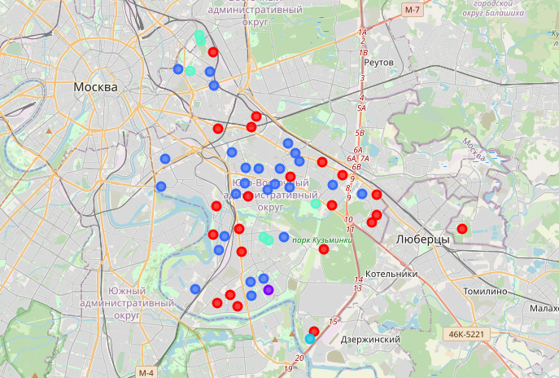

New York City

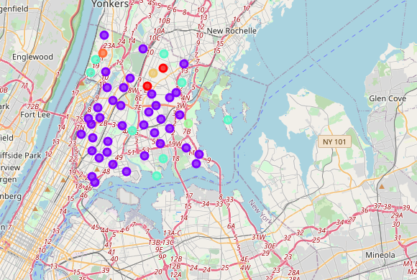

If we will try to compare results by colors - we can see that these two areas have nothing similar. Let's inspect frequency of each cluster in both cities:

New York City clusters and frequency:

1 39

4 8

0 2

7 1

6 1

5 1

Moscow clusters and frequency:

2 26

0 22

4 6

3 1

1 1

Most popular clusters in NY are 1 and 4 (and it's 39+8=47 places (47/52*100% = 90,4% of all)) and most popular clusters in Moscow are 2 and 0 (it's 26+22=48 places (85,7% of all), very similar quantity to NY).

Let's inspect most common venues in each of these four cluster.